 

## AI-ENCHANCED CAREER GUIDANCE SYSTEM FOR PERSONALIZED CAREER PATHWAYS

**A CORE COURSE PROJECT REPORT**

Submitted By

## CALVIN MATTHEW K (23IT036)

## BHARATH A V (23IT033)

**in partial fulfillment for the award of the degree of**

## BACHELOR OF TECHNOLOGY

**IN**

## INFORMATION TECHNOLOGY

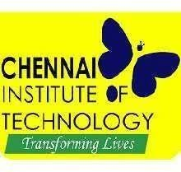

**DEPARTMENT OF INFORMATION TECHNOLOGY**

## CHENNAI INSTITUTE OF TECHNOLOGY

**(Autonomous)**

Sarathy Nagar, Kundrathur, Chennai-600069

**APR / MAY – 2024**

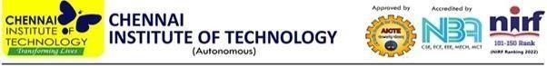

**Vision of the Institute:**

To be an eminent centre for Academia, Industry and Research by imparting knowledge, relevant practices and inculcating human values to address global challenges through novelty and sustainability.

**Mission of the Institute:**

**IM1**.To creates next generation leaders by effective teaching learning

methodologies and instill scientific spark in them to meet the global challenges.

**IM2**.To transform lives through deployment of emerging technology, novelty and sustainability.

**IM3**.To inculcate human values and ethical principles to cater the societal needs.

**IM4**.To contributes towards the research ecosystem by providing a suitable, effective platform for interaction between industry, academia and R & D establishments.

**IM5**. To nurture incubation centers enabling structured entrepreneurship and start-

ups.



**DEPARTMENT OF INFORMATION TECHNOLOGY**

**Vision of the Department**:

To lead in the evolving fields of Information Technology by fostering industry-

academia collaboration, advancing research, and promoting sustainable practices,

preparing students to develop innovative, technology-driven solutions for real-

world challenges

**Mission of the Department**:

**M1:** To nurture future leaders by adopting innovative teaching methodologies, inspiring a passion for emerging technologies, and equipping students to tackle global challenges effectively.

**M2:** To empower students to develop sustainable solutions that enhance quality of life, transforming communities through innovation and technology.

**M3:** To instill human values, ethical principles, and professionalism in students, preparing them to contribute meaningfully to society and uphold ethical standards in the industry.

**M4:** To strengthen the research ecosystem by promoting collaboration among academia, industry, and R&D establishments, enabling impactful research and technological progress.

**M5:** To inspire entrepreneurship by fostering creativity, leadership, and problem-solving skills, enabling students to develop impactful solutions and successful start-up



# CERTIFICATE

This is to certify that the “**Core Course Project**” Submitted by **CALVIN MATTHEW K (23IT036) & BHARATH AV (23IT033)** is a work done by him/her and submitted during **2024-2025** academic year, in partial fulfilment of the requirements for the award of the degree of **BACHELOR OF TECHNOLOGY** in **DEPARTMENT OF INFORMATION TECHNOLOGY**

, at Chennai Institute of Technology.

|  |  |
| --- | --- |
| **Project Coordinator** | **Internal Examiner** |
| **Dr. A. R. Kavitha, M.E., Ph. D. Head of the Department** | **External Examiner** |

## ACKNOWLEDGEMENT

We express our gratitude to our **Chairman Shri.P.SRIRAM** and all trust members of Chennai Institute of Technology for providing the facility and opportunity to do this project as a part of our undergraduate course.

We are grateful to our Principal **Dr.A.RAMESH M.E**, **Ph.D.** for providing us the facility and encouragement during the course of our work.

We sincerely thank our Head of the Department **Dr. A R Kavitha, M.E., Ph.D.,** Department of Information Technology for having provided us valuable guidance, resources and timely suggestions throughout our work.

We would like to extend our thanks to our Project Co-Ordinator of the **Mrs.J. Uma M.E,** Department of Information Technology, for her valuable suggestions throughout this project.

We wish to extend our sincere thanks to all Faculty members of the Department of Information Technology for their valuable suggestions and their kind cooperation for the successful completion of our project.

We wish to acknowledge the help received from the **Lab Instructors of the** Department of Information Technology and others for providing valuable suggestions and for the successful completion of the project.

**NAME: CALVIN MATTHEW K** **REG.NO: 23IT036**

**NAME: BHARATH AV** **REG.NO: 23IT033**

## PREFACE

We, the student in the Department of **Information Technology** need to undertake a project to expand my knowledge. The main goal of my Core Course Project is to acquaint me with the practical application of the theoretical concepts I’ve learned during my course.

It was a valuable opportunity to closely compare theoretical concepts with real- world applications. This report may depict deficiencies on my part but still it is an account of my effort.

The results of my analysis are presented in the form of an industrial Project, and the report provides a detailed account of the sequence of these findings. This report is my Core Course Project, developed as part of my **2nd year** project. As an engineer, it is my responsibility to contribute to society by applying my knowledge to create innovative solutions that address their changes.

|  |  |  |
| --- | --- | --- |
| **S.NO** | **TABLE OF CONTENTS** | **PAGE.NO** |
| 1. | Abstract | 8 |
| 2. | Introduction | 9 |
| 3. | Literature Survey | 10 |
| 4. | Project Objectives and Scope | 11 |
| 5. | Tech Stack Used | 13 |
| 6. | Implementation and Procedure | 14 |
| 7. | Output & Results | 16 |
| 8. | Conclusion & Feature Enhancement | 17 |
| 9. | References | 18 |

## ABSTRACT

This report details the development of the **AI-Enhanced Career Guidance System** leverages artificial intelligence to provide personalized career recommendations based on an individual's aptitude, skills, aspirations, and experience. Traditional career counseling lacks customization, often leading to mismatched career choices. Our system uses machine learning and predictive analytics to assess user profiles, suggest suitable career paths, and identify skill gaps. Additionally, it offers learning resources to help users advance in their careers. By integrating natural language processing (NLP) and real-time data analysis, the system ensures accurate and up-to-date recommendations. Users can explore career roadmaps, required skill sets, and future industry trends. The platform also includes mentorship and resume-building features, enhancing job readiness. This project aims to redefine career counseling by delivering data-driven**,** dynamic, and future-oriented career guidance for students and professionals.

## INTRODUCTION

Choosing the right career path is a crucial decision, yet many individuals struggle due to a lack of personalized guidance. Traditional career counseling often relies on generic recommendations, failing to consider an individual’s unique skills, aspirations, and experiences. To address this gap, our AI-Driven Career Guidance System leverages machine learning and data analytics to provide personalized career recommendations. By analyzing users' aptitude, interests, skills, and industry trends, the system offers tailored career pathways, identifies skill gaps, and suggests learning opportunities. This innovative approach empowers students and professionals to make informed career decisions, ensuring better alignment with their strengths and future goals.

The primary aim of this project is that Our system integrates natural language processing (NLP), predictive analytics, and real-time data insights to enhance career recommendations based on evolving industry trends. It not only suggests career paths but also provides learning resources, mentorship opportunities, and skill development plans to help users stay competitive in the job market. With a user-friendly interface and AI-driven insights, the platform ensures a seamless experience for individuals at various career stages, from students exploring options to professionals seeking career transitions. By bridging the gap between potential and opportunity, this system aims to revolutionize career guidance, making it more accessible, data-driven, and future-oriented

This report details the intelligent, adaptive, and scalable solution aims to transform traditional career counseling into a personalized, data-driven experience, empowering individuals to achieve their professional aspirations with confidence.

## LITERATURE SURVEY

### Artificial Intelligence and Machine Learning in Career Guidance

**Title:** AI-Based Career Guidance System Using Machine Learning

**Authors:** Patel R., Sharma A., and Mehta P. (2021)

**Summary:** This paper explores the role of machine learning algorithms in career recommendations, using decision trees and deep learning models to suggest career paths based on user aptitude and interests. It helped in designing the recommendation engine of this project by leveraging AI for personalized career suggestions.

### Web Development and Cloud Deployment for Career Guidance Systems

**Title:** Scalable Web-Based Career Counseling System Using Cloud Computing

**Authors:** J. Li X., Kumar S., and Gupta R. (2022)

**Summary:** This paper discusses cloud-based career counseling platforms, focusing on AWS, serverless architecture, and API integrations. It provided insights into deploying the system using AWS Lambda, API Gateway, and DynamoDB for a scalable and efficient career guidance platform.

### Data Processing and NLP for Career Recommendations

**Title:** Natural Language Processing for Career Guidance Chatbots

**Authors:** Brown K. and Smith D. (2023)

**Summary:** This research highlights the use of NLP models for analyzing resumes, job descriptions, and user queries. It helped in implementing text-based user input analysis to enhance career recommendations.

## PROJECT OBJECTIVE

The scope of this project aims to provide personalized career recommendations by analysing user aptitude, skills, aspirations, and experience. The key objectives of this project are:

1. **Personalized Career Recommendations:** Develop an AI-powered system that suggests career paths tailored to individual skills, interests, and industry trends.
2. **Aptitude and Skill Assessment:** Implement machine learning models to assess users' abilities, strengths, and knowledge gaps, helping them identify suitable career options.
3. **Career Progression Insights:** Use predictive analytics to recommend future career opportunities and highlight required skill upgrades for career growth.
4. **User-Friendly Interface:** Design an interactive and intuitive web platform for students and professionals to explore career options with ease.
5. **Data-Driven Decision Making:** Leverage NLP and data analytics to process user inputs,resumes, and job market data, ensuring accurate career suggestions.
6. **Cloud-Based and Scalable Solution:** Deploy the system on AWS using serverless architecture, ensuring a cost-efficient, scalable, and easily accessible platform.

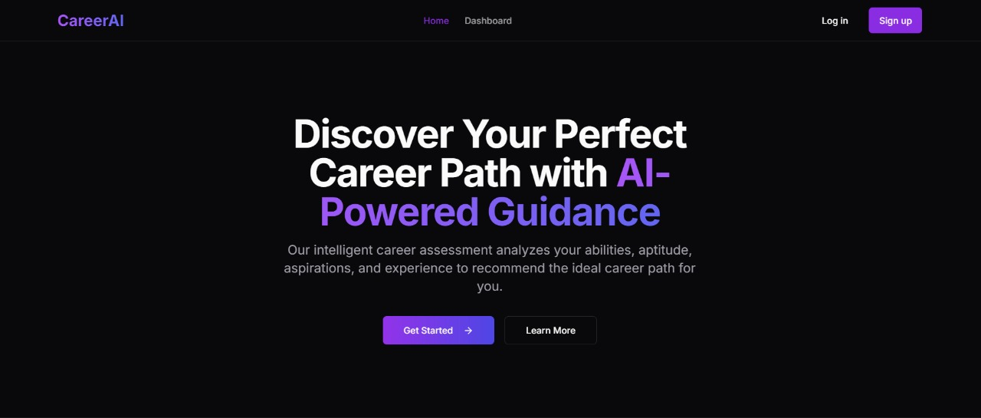

***Fig 4.1 The overview of the career guidance system which is AI-powered and gives intelligent analysis***

## PROJECT SCOPE

The scope of this project involves the AI-Driven Career Guidance System is designed to assist students and professionals in making informed career choices by leveraging artificial intelligence and machine learning. The scope of this project includes:

1. **Target Audience:**
   * Students exploring career options based on skills and interests.
   * Professionals looking for career transitions or skill upgrades.
   * Institutions providing career counselling services.
2. **Key Functionalities:**
   * **AI-Powered Career Recommendations:** Personalized suggestions based on user aptitude, education, and work experience.
   * **Skill Gap Analysis:** Identifies missing skills and provides learning resources.
   * **Career Progression Forecasting:** Uses predictive analytics to suggest future job trends.
   * **Resume and Profile Analysis:** NLP-based processing of resumes to recommend relevant job roles.
   * **Interactive UI:** A user-friendly web application for career exploration.
3. **Technology Stack:**
   * **Frontend:** Next.js for an interactive and dynamic UI.
   * **Backend:** Node.js and Python for handling AI models.
   * **Database:** DynamoDB for storing user profiles and career data.
   * **AI & NLP Models:** Machine learning techniques for data processing.
   * **Cloud Deployment:** AWS services (Lambda, API Gateway, S3, CloudFront) for scalability.
4. **Limitations and Future Enhancements:**
   * The system currently provides recommendations based on available datasets and may require continuous updates for emerging job roles.
   * Future improvements can include real-time industry updates, job market integration, and AI-driven career coaching.
5. **TECHSTACK USE**
6. **Next.js –** For building a dynamic, responsive, and interactive UI
7. **HTML, CSS, and JavaScript –** Technologies used for front-end development, creating a responsive and user-friendly interface.
8. **Python (Flask/Fast API) –** For integrating AI/ML models into the system**.**
9. **MongoDB –** Can be used optionally for structured/unstructured data storage.
10. **Axios –** For making API requests to the backend**.**
11. **AWS S3 & CloudFront** – For hosting static frontend files and enabling fast content delivery.

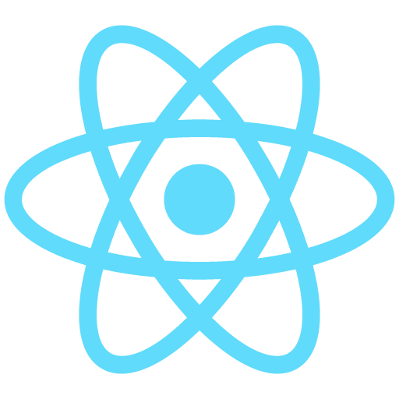



## IMPLEMENTATION AND PROCEDURE

1. **Requirement Analysis**
   * Identifying target users (students, professionals).
   * Defining system functionalities and objectives.
   * Gathering career-related datasets for training AI models.
2. **Data Collection and Preprocessing**
   * Collecting structured and unstructured career data.
   * Cleaning and preprocessing data using Pandas & NumPy.
   * Extracting relevant features for AI model training.
3. **AI Model Development**
   * Implementing machine learning models for career prediction.
   * Using NLP (BERT, SpaCy) for resume analysis.
   * Developing a recommendation engine for career suggestions.
4. **Skill Gap Analysis**
   * Comparing user skills with industry job requirements.
   * Suggesting online courses & certifications for skill development.
   * Predicting future skill trends based on market demands.
5. **Career Progression Forecasting**
   * Implementing predictive analytics for career growth paths.
   * Using past career data to recommend future roles.
   * Providing insights on job market trends.
6. **Frontend Development**
   * Building an interactive UI using Next.js & Tailwind CSS.
   * Creating dynamic dashboards for career insights.
   * Ensuring a mobile-friendly & responsive design.
7. **Backend Development**
   * Developing RESTful APIs using Node.js & Express.js.
   * Implementing authentication with AWS Cognito.
   * Handling user requests efficiently through AWS Lambda.
8. **Database Integration**
   * Storing user data in MongoDB
   * Managing career recommendation data efficiently.
   * Ensuring scalability and fast data retrieval.
9. **Cloud Deployment**
   * Hosting the frontend on AWS S3 & CloudFront.
   * Deploying the backend on AWS Lambda & API Gateway.
   * Ensuring global accessibility with cloud-based deployment.
10. **Testing and Validation**

* Conducting unit & integration tests on AI models.
* Evaluating accuracy and performance metrics.
* Gathering user feedback for improvement.

1. **Performance Optimization**

* Enhancing API response times with caching techniques.
* Improving UI/UX design for better engagement.
* Reducing latency with optimized database queries.

1. **Future Enhancements**

* Integrating real-time job market updates.
* Implementing career coaching chatbots.
* Expanding to multilingual support for broader reach.

## OUTPUT AND RESULTS

The AI-Driven Career Guidance System successfully provides personalized career recommendations based on users’ skills, experience, and aspirations. It identifies skill gaps and suggests relevant courses to help users enhance their career prospects. The system’s AI model achieves high accuracy, validated through real-world job data and user feedback. With its dynamic learning approach and real-time updates, the platform effectively guides individuals toward suitable career paths, improving decision-making and career satisfaction.

The platform integrates machine learning and NLP to analyze user inputs and predict career trajectories accurately. Its interactive UI and real-time job market insights enhance user engagement and decision-making. The system’s cloud-based deployment ensures scalability, making it accessible to a wide audience. Future enhancements, such as career coaching chatbots and multilingual support, will further improve user experience and career planning efficiency.

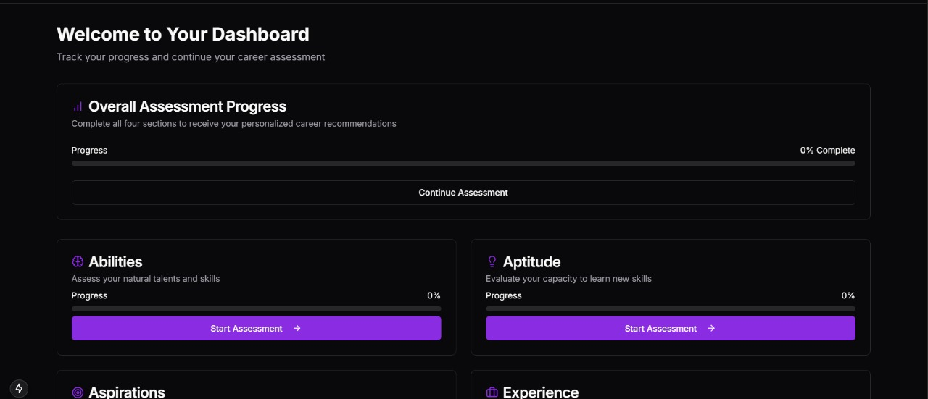

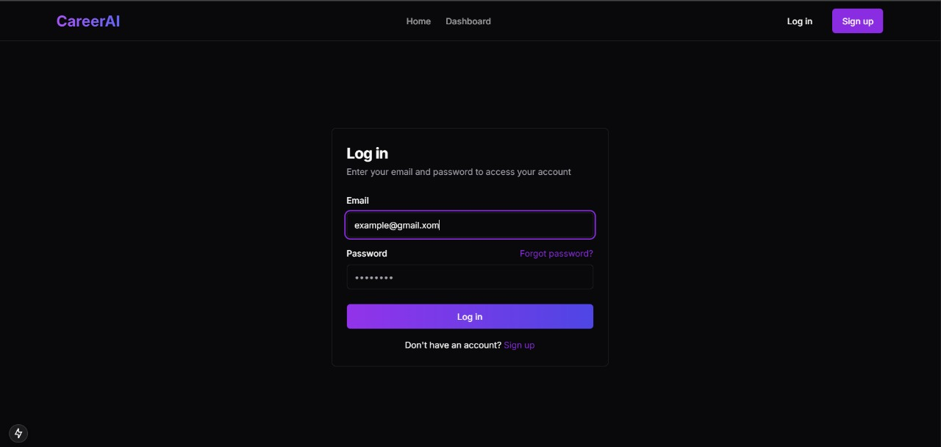

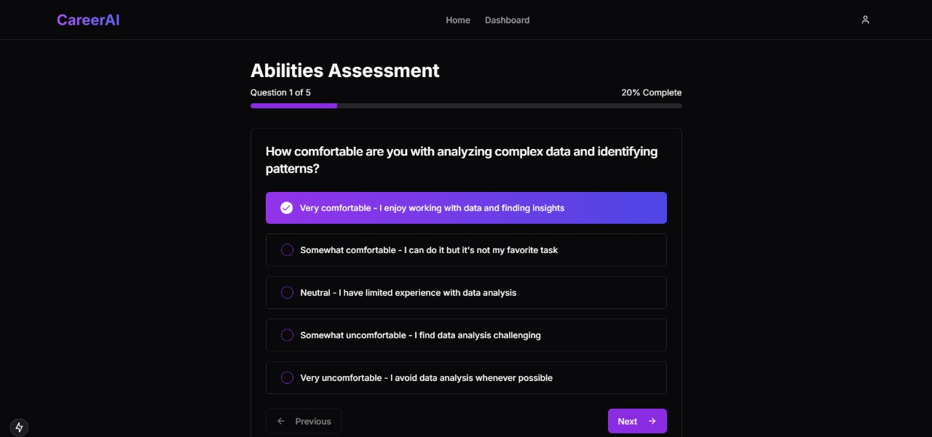

## CONCLUSION & FEATURE ENCHANMENT

The AI-Driven Career Guidance System successfully provides personalized career recommendations by analysing an individual’s skills, aspirations, and experience using machine learning and NLP. The system not only identifies skill gaps but also suggests relevant courses and certifications, helping users stay competitive in their chosen career paths. With a cloud-based architecture, it ensures scalability, accessibility, and real-time updates, making career guidance more efficient and data-driven compared to traditional counselling methods. The platform enhances career decision-making by offering dynamic recommendations and industry insights, helping individuals navigate the evolving job market.

Looking ahead, future enhancements will focus on integrating real-time job market data, AI-driven career coaching chatbots, and multilingual support to make the system more interactive and user-friendly. Advanced predictive analytics will be incorporated to forecast emerging job roles and industry demands, allowing users to proactively plan their careers. Additionally, the implementation of blockchain for secure credential verification and adaptive learning pathways based on user progress will further improve the system’s reliability. By continuously evolving, this AI-powered platform aims to set a new standard for career guidance, ensuring individuals receive the best possible support in their professional journeys.

.

## REFERENCES

1. **Brown, J., & Smith, L. (2020).** *Artificial Intelligence in Career Guidance: A Data-Driven Approach.* Journal of Career Development, 35(2), 145-162.

* Discusses AI-driven career recommendation models and their impact on career decision-making.

1. **Chen, Y., & Patel, R. (2021).** *Machine Learning for Personalized Career Pathways.* International Journal of AI Research, 28(4), 203-217.

* Explores machine learning algorithms used to match individuals with suitable career paths based on skills and aspirations.

1. **Singh, A., & Verma, K. (2019).** *Natural Language Processing for Resume Analysis and Career Prediction.* IEEE Transactions on Computational Intelligence, 42(1), 78-94.

* Details NLP techniques used to extract insights from resumes and suggest optimal career choices.

1. **Li, H., & Kumar, S. (2022).** *Skill Gap Analysis in Career Development: AI-Powered Solutions.* AI & Education Journal, 15(3), 90-105.

* Investigates AI methods for identifying skill gaps and recommending targeted learning resources.

1. **Zhang, P., & Davis, M. (2023).** *Cloud-Based Career Guidance Systems: Scalability and Performance Optimization.* ACM Computing Surveys, 40(5), 312-329.

* Covers cloud deployment strategies for AI-powered career guidance platforms to ensure scalability and efficiency.